Accident analysis project report

Accident Analysis Project

Project Report

Accidental Analysis Project Report

Accidental Analysis Project

Project Report

Table of Contents
Data Set 2

Accidents Data (1979-2013) 2

Make (2009-2012) 3

Pre-requisite 4

Components used 4

Objective 5

Conclusion 5

Project Flow 6

Phase 1 6

Phase 2 9

Accident file operation 9

Make File Operation 10

Joining Accident and Make Files 11

Make Report 11

Day Report 11

Light Report 12

Road Surface Report 12

Road_Type Report 12

Speed_Limit Report 12

Severity Report 13

No_of_casulties/Accident Report 13

Phase 3 14

Phase 4 18

Accidental Analysis Project Report

Data Set

These files provide detailed road safety data about the circumstances of personal injury road accidents from 1979 -2013

Following data files are present in this dataset:

Accidents Data (1979-2013)

This data set consists of around 30 columns and around 78 lac rows

- We have picked few columns like:

  - Accident index

  - Road type

  - Road surface

  - Severity

  - Light conditions

  - Days of the week

  - No of casualty per accident

- Following is the glimpse of the raw data:

FIGURE 1-1

Accidental Analysis Project Report

Make (2009-2012)

This dataset consists of 25 columns and around 10 lac of records

- We have picked few columns like:

  - Accident index

  - Make

- Following is the glimpse of the raw data:

FIGURE 1-2

The statistics relate only to personal injury accidents on public roads that are reported to the police, and subsequently recorded, using the STATS19 accident reporting form.

Accidental Analysis Project Report

Pre-requisite

- Hadoop framework

- Map-reduce

- Pig

- Flume

- Sqoop

- jsp/servlet

- Data warehousing concepts

Components used

- Hadoop framework

- Map-reduce

- Pig

- Flume

- Sqoop

- jsp/servlet

- jfreechart

- Mysql

Accidental Analysis Project Report

Objective

To find the number of accidents happened:

- in various weather conditions

- in various light conditions

- in various road surface conditions

- with make information of the accident vehicles

- during various days of week

- on various road types

- Number of casualties per accident per year

- Number of accidents happening at various speed limits

Conclusion

By using above data we can predict and make some decision to:

- Reduce accidents under the circumstances where more no. Of accidents are happening

- We can put up some kind of sign boards or make people aware of such circumstances so that they may be alert in such conditions

Accidental Analysis Project Report

Project Flow

Phase 1
Putting input files from source to HDFS using Flume

Note: You should have flume installed at your machine to run the following command

FIGURE 1-3
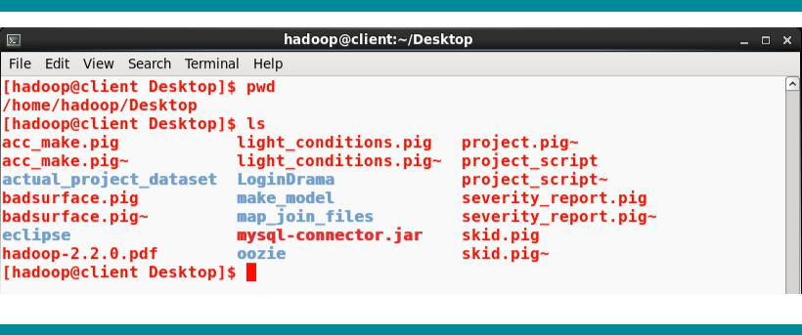

FIGURE 1-4

Accidental Analysis Project Report
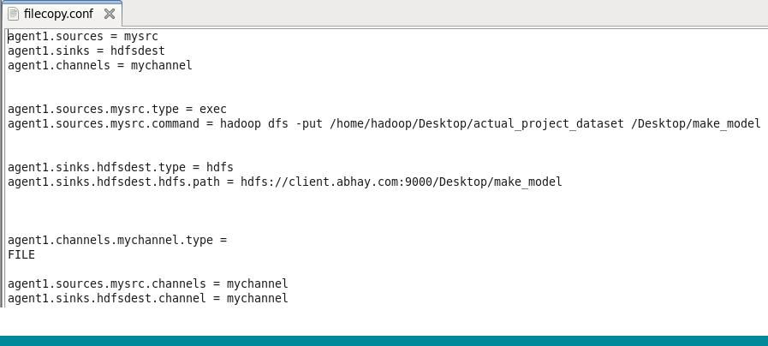

FIGURE 1-5
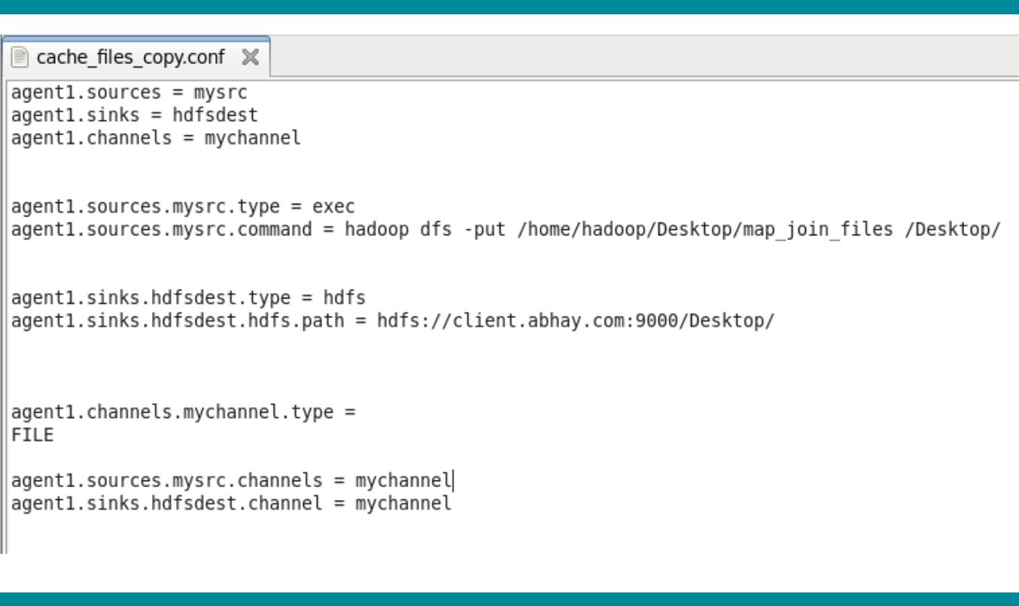

Command: | flume-ng agent -n agent1 -c conf -f flume/conf/filecopy.conf
FIGURE 1-6
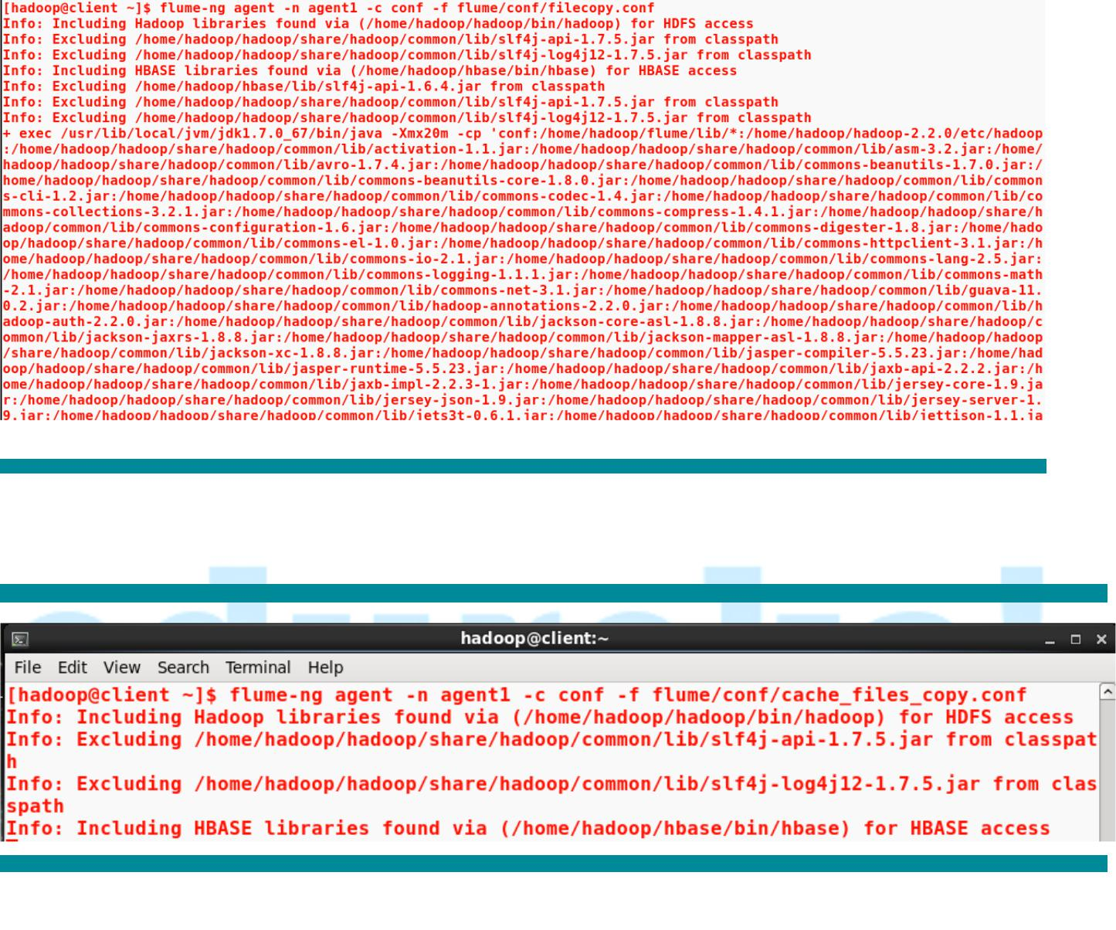

Command: flume-ng agent -n agent1 -c conf -f flume/conf/cache_file_copy.conf

FIGURE 1-7

Accidental Analysis Project Report

FIGURE 1-8

Phase 2
Processing input files from HDFS and putting the processed files back to HDFS

Command: pig Desktop/acc_make.pig

Accident file operation
/*-------------------------------------------------------------------------*/

rmf /Desktop/output/accident_map_joined_complete_out

accident = load '/Desktop/make_model/Accidents7913.csv' using PigStorage(',');

accident_schema = foreach accident generate $0 as index,SUBSTRING($0,0,4) as year,$6 as severity,$8 as no_of_cas,$10 as dow,$16 as road_type,$17 as speed_limit,$24 as light_cond,$25 as weather_cond,$26 as road_surface_cond;

accident_year = filter accident_schema by (int)light_cond >-1 AND (int)weather_cond <9 AND (int)road_type >-1 AND (int)road_surface_cond >-1;

--dump accident_schema;

severity_ty = load '/Desktop/severity';

joined_severity_ty = join accident_year by $2,severity_ty by $0 using 'replicated';

Accidental Analysis Project Report

road_ty = load '/Desktop/road_type';

joined_road_ty = join joined_severity_ty by $5,road_ty by $0 using 'replicated';

dow_ty = load '/Desktop/dow';

joined_dow_ty = join joined_road_ty by $4,dow_ty by $0 using 'replicated';

light_ty = load '/Desktop/light_cond';

joined_light_ty = join joined_dow_ty by $7,light_ty by $0 using 'replicated';

road_surface_ty = load '/Desktop/road_surface';

joined_road_surface_ty = join joined_light_ty by $9,road_surface_ty by $0 using 'replicated';

weather_ty = load '/weather_index.dat';

joined_weather_ty = join joined_road_surface_ty by $8,weather_ty by $0 using 'replicated';

map_joined_out = foreach joined_weather_ty generate $0,$1,$3,$6,$11,$13,$15,$17,$19,$21;

store map_joined_out into '/Desktop/output/accident_map_joined_complete_out' using PigStorage(',')

/*-------------------------------------------------------------------------*/

Make File Operation
/*-------------------------------------------------------------------------*/

make = load '/Desktop/make_model/model0912' using PigStorage(',');

make_schema = foreach make generate $0 as index,SUBSTRING($0,0,4) as year,$22 as make; store make_schema into '/Desktop/output/make_csv' using PigStorage(',');

/*-------------------------------------------------------------------------*/

Accidental Analysis Project Report

Joining Accident and Make Files

/*-------------------------------------------------------------------------*/

complete_accident = load '/Desktop/output/accident_map_joined_complete_out' using

PigStorage(',') as

(ac_index:chararray,year:int,no_of_cas:int,severity:chararray,road_type:chararray,day:chararray,ligh

t:chararray,surface:chararray,weather:chararray);

complete_make = load '/Desktop/output/make_csv' using PigStorage(',') as (ac_index:chararray,year:int,make:chararray);

combined_accident_make = join complete_accident by $0 LEFT OUTER,complete_make by $0;

/*-------------------------------------------------------------------------*/

Make Report

/*-------------------------------------------------------------------------*/ grp_make = group combined_accident_make by ($1,$11);

out = foreach grp_make generate FLATTEN(group),COUNT(combined_accident_make);

store out into '/Desktop/output/report/make_report' using PigStorage(',');

/*-------------------------------------------------------------------------*/

Day Report

/*-------------------------------------------------------------------------*/ grp_make = group combined_accident_make by ($1,$6);

out = foreach grp_make generate FLATTEN(group),COUNT(combined_accident_make);

store out into '/Desktop/output/report/Day_report' using PigStorage(',');

/*-------------------------------------------------------------------------*/

Accidental Analysis Project Report

Light Report

/*-------------------------------------------------------------------------*/ grp_make = group combined_accident_make by ($1,$7);

out = foreach grp_make generate FLATTEN(group),COUNT(combined_accident_make); store out into '/Desktop/output/report/light_report' using PigStorage(',');

/*-------------------------------------------------------------------------*/

Road Surface Report

/*-------------------------------------------------------------------------*/ grp_make = group combined_accident_make by ($1,$8);

out = foreach grp_make generate FLATTEN(group),COUNT(combined_accident_make); store out into '/Desktop/output/report/road_surface_report' using PigStorage(',');

/*-------------------------------------------------------------------------*/

Road_Type Report

/*-------------------------------------------------------------------------*/

grp_make = group combined_accident_make by ($1,$5);

out = foreach grp_make generate FLATTEN(group),COUNT(combined_accident_make); store out into '/Desktop/output/report/road_type_report' using PigStorage(',');

/*-------------------------------------------------------------------------*/

Speed_Limit Report

/*-------------------------------------------------------------------------*/

grp_make = group combined_accident_make by ($1,$3);

out = foreach grp_make generate FLATTEN(group),COUNT(combined_accident_make); store out into '/Desktop/output/report/speed_limit_report' using PigStorage(',');

/*-------------------------------------------------------------------------*/

Accidental Analysis Project Report

Severity Report

/*-------------------------------------------------------------------------*/

grp_make = group combined_accident_make by ($1,$4);

out = foreach grp_make generate FLATTEN(group),COUNT(combined_accident_make);

store out into '/Desktop/output/report/severity_report' using PigStorage(','); /*-------------------------------------------------------------------------*/

No_of_casulties/Accident Report

/*-------------------------------------------------------------------------*/ grp_make = group combined_accident_make by ($1,$2);

out = foreach grp_make generate FLATTEN(group),SUM(combined_accident_make.$2); store out into '/Desktop/output/report/no_of_casulties_report' using PigStorage(',');

Accidental Analysis Project Report

Phase 3
Exporting the ordered output in some DBMS server (here MySQL) using sqoop


Note: please refer to HDFS – MySQL sqoop export document before executing the following exercise.

Command: For each file shown above in hdfs prepare a table as per the input file’s schema under a database called hadoop_project in MySQL before executing export command:

FIGURE 1-11

Exporting make file into a table called make in MySql:

Command: sqoop export --connect jdbc:mysql://192.168.230.1/hadoop_project --username root -P --table make --export-dir /Desktop/output/report/make_report

FIGURE 1-12
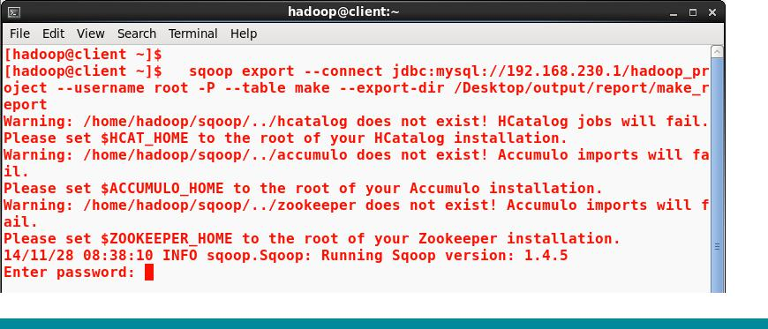

Accidental Analysis Project Report

Exporting Day_report file into a table called dow in MySql:

Command: sqoop export --connect jdbc:mysql://192.168.230.1/hadoop_project --username root -P --table dow --export-dir /Desktop/output/report/Day_report

FIGURE 1-13

Exporting light_report file into a table called light in MySql:

Command: sqoop export --connect jdbc:mysql://192.168.230.1/hadoop_project --username root -P --table light --export-dir /Desktop/output/report/light_report

FIGURE 1-14

Accidental Analysis Project Report

Exporting road_surface file into a table called road_surface in MySql:

Command: sqoop export --connect jdbc:mysql://192.168.230.1/hadoop_project --username root - P --table road_surface --export-dir /Desktop/output/report/road_surface_report2

FIGURE 1-15
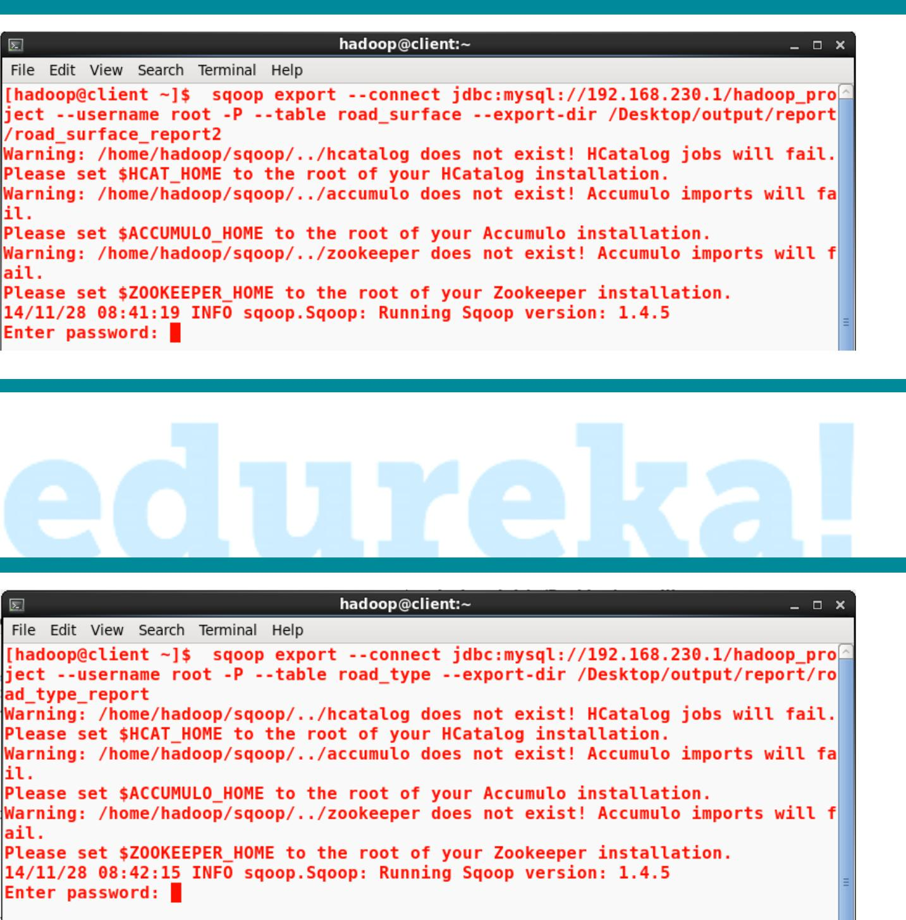

Exporting road_type file into a table called road_type in MySql:

Command: sqoop export --connect jdbc:mysql://192.168.230.1/hadoop_project --username root - P --table road_type --export-dir /Desktop/output/report/road_type_report

FIGURE 1-16

Accidental Analysis Project Report

Exporting severity file into a table called severity in MySql:

Command: sqoop export --connect jdbc:mysql://192.168.230.1/hadoop_project --username root - P --table severity --export-dir /Desktop/output/report/severity_report

FIGURE 1-17
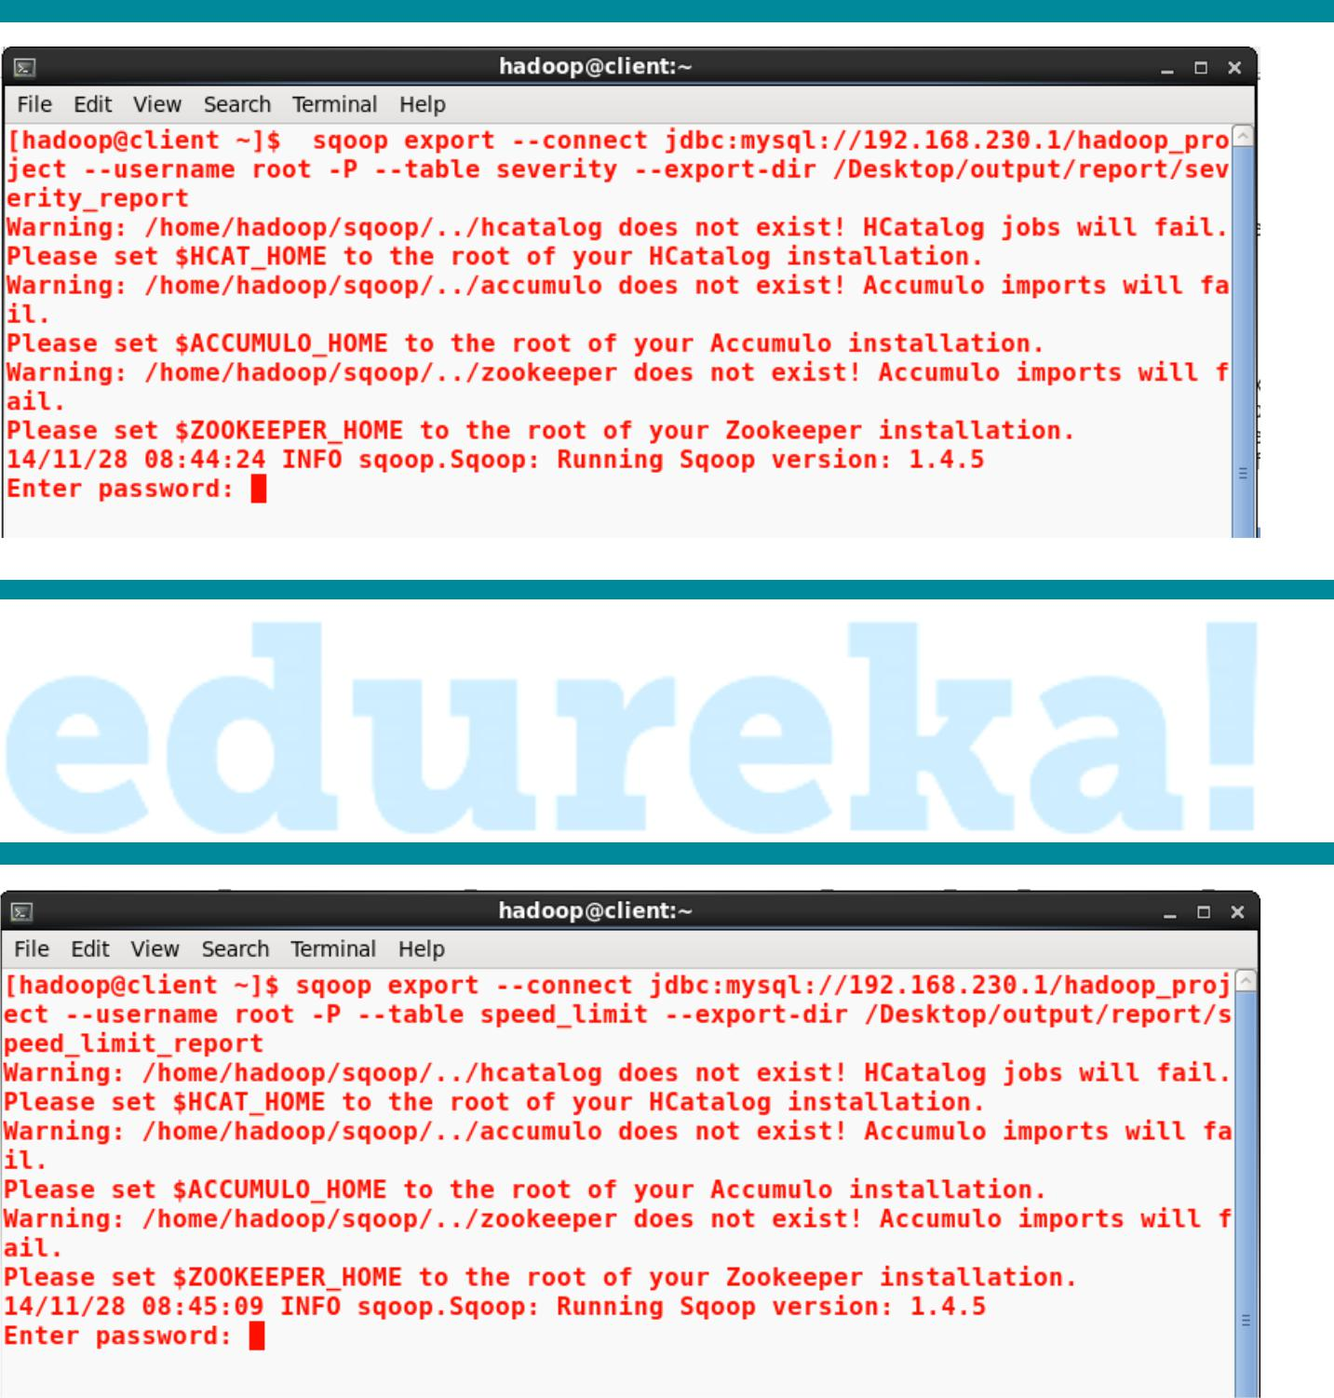

Exporting speed_limit file into a table called speed_limit in MySql:

Command: sqoop export --connect jdbc:mysql://192.168.230.1/hadoop_project --username root - P --table speed_limit --export-dir /Desktop/output/report/speed_limit_report

FIGURE 1-18

Accidental Analysis Project Report

Exporting cuasualty per accident file into a table called no_of_cas in MySql:

Command: sqoop export --connect jdbc:mysql://192.168.230.1/hadoop_project --username root - P --table no_of_cas --export-dir /Desktop/output/report/no_of_casulties_report

FIGURE 1-18

Phase 4
Integrating the data to a real time application (Here a web application) and generating

Graph

Login Page

Accidental Analysis Project Report

Home Page
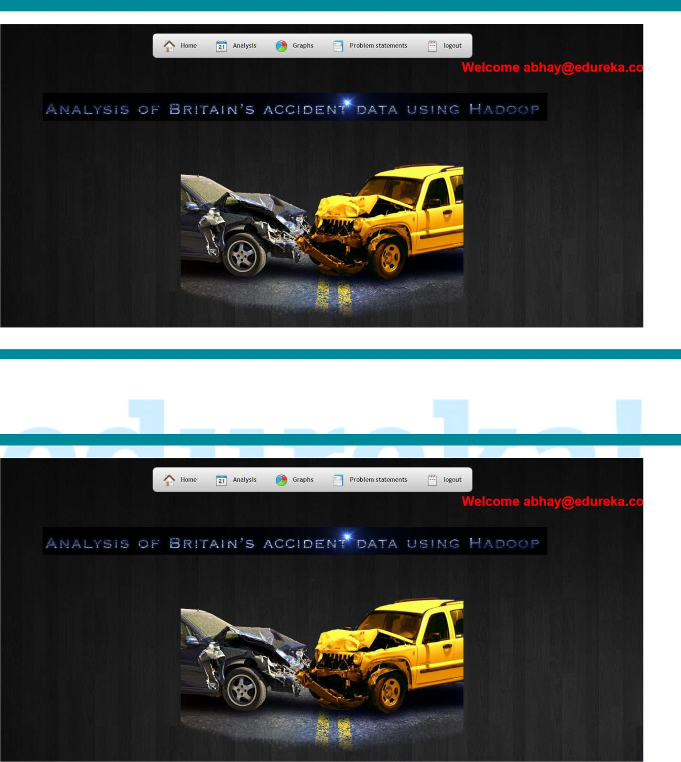

Data_Page

Accidental Analysis Project Report

Day wise report:
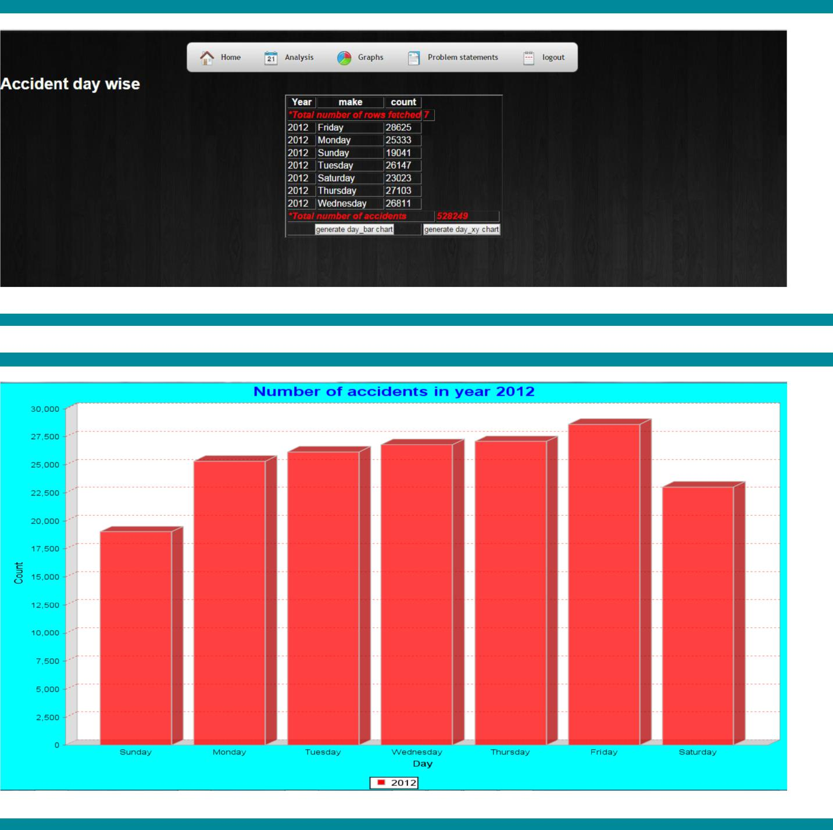

Accidental Analysis Project Report
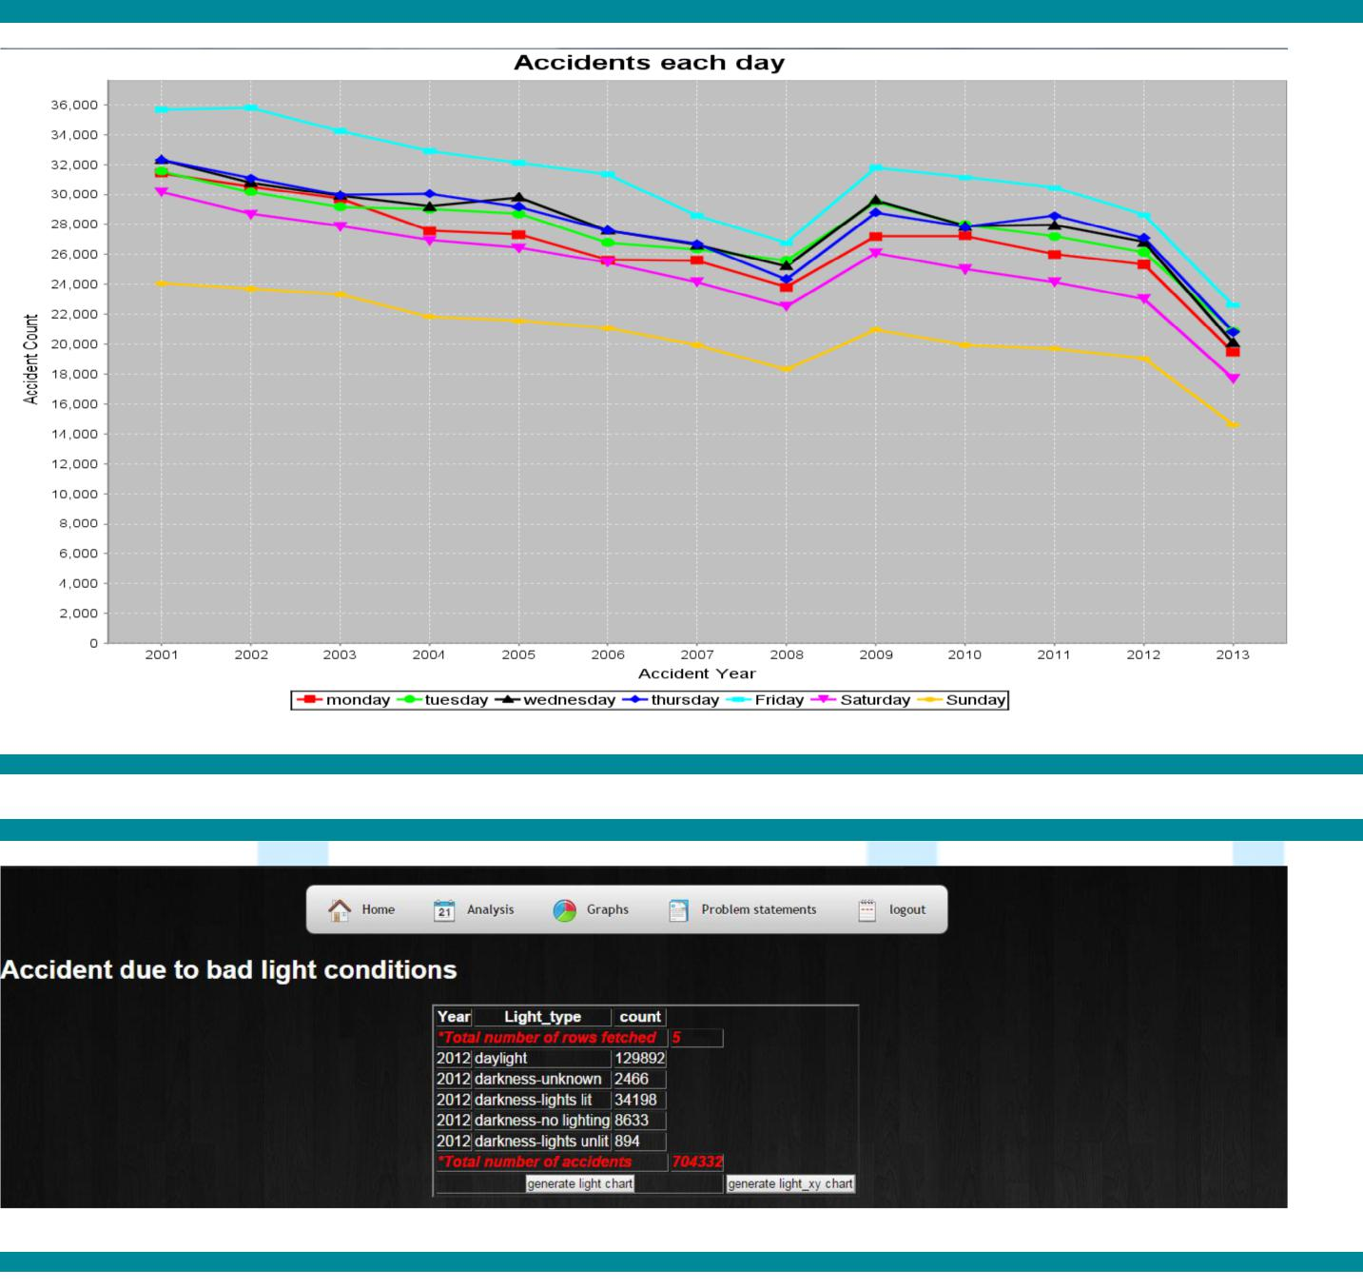

Accidental Analysis Project Report
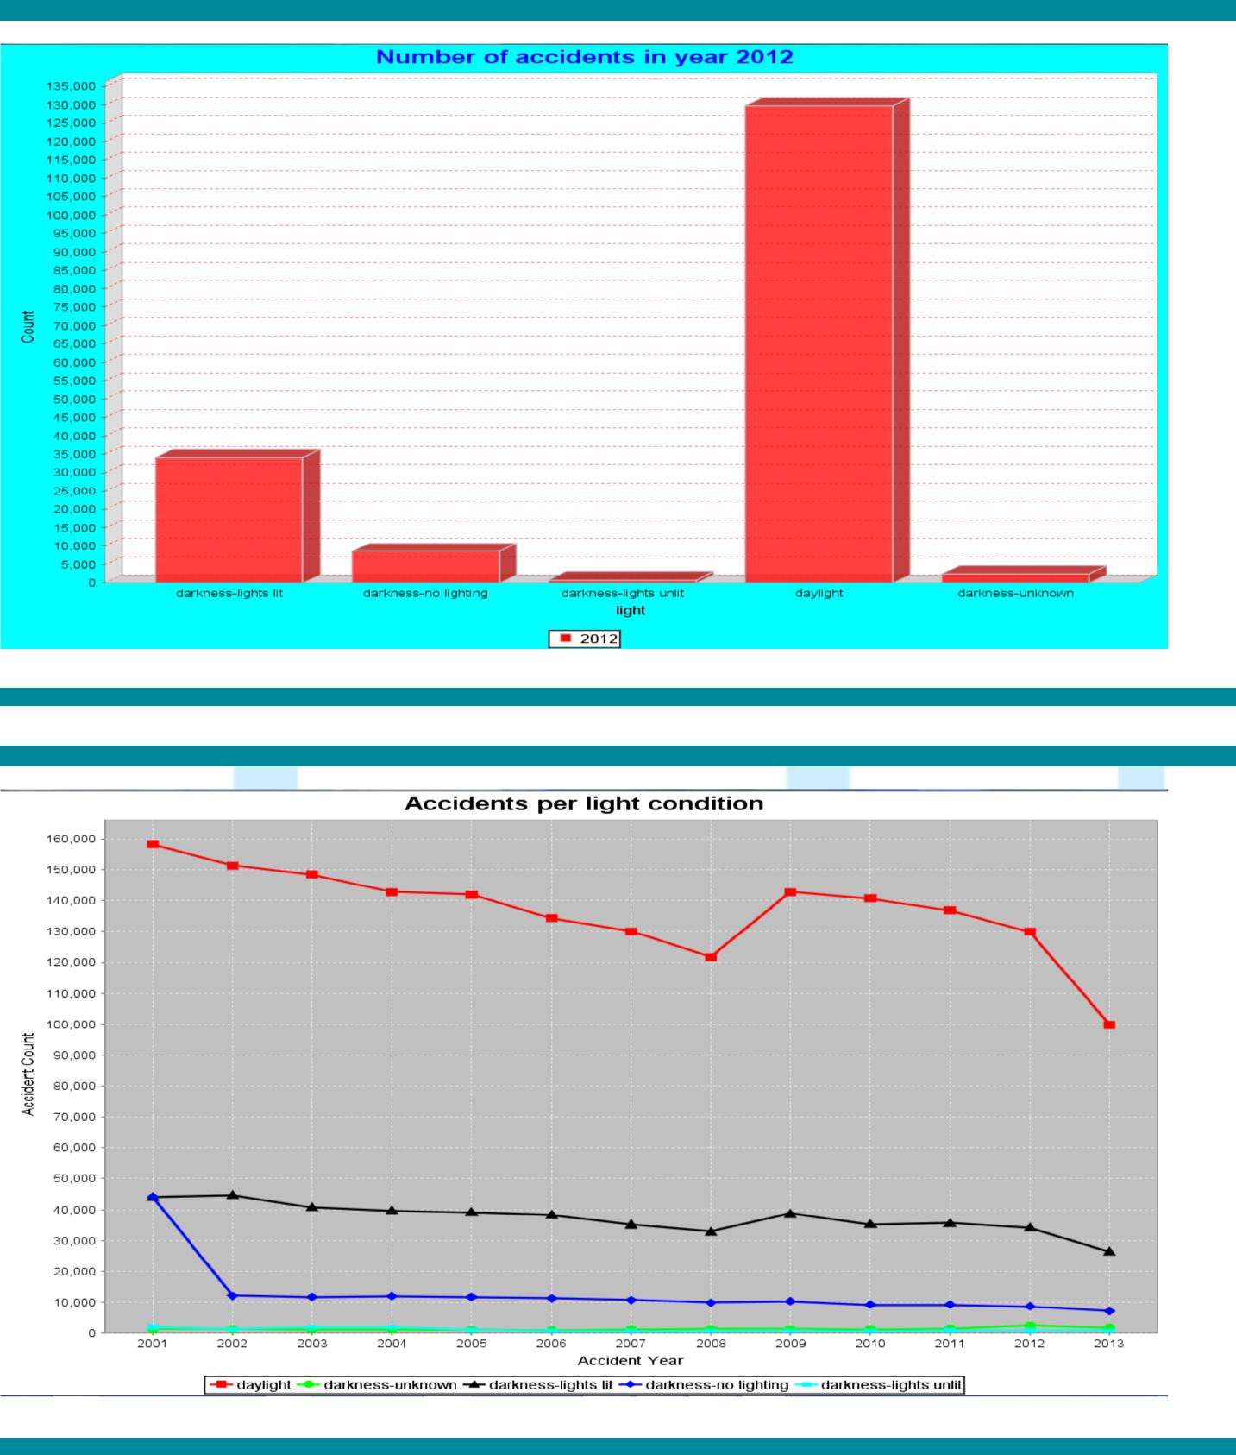

Accidental Analysis Project Report

Make
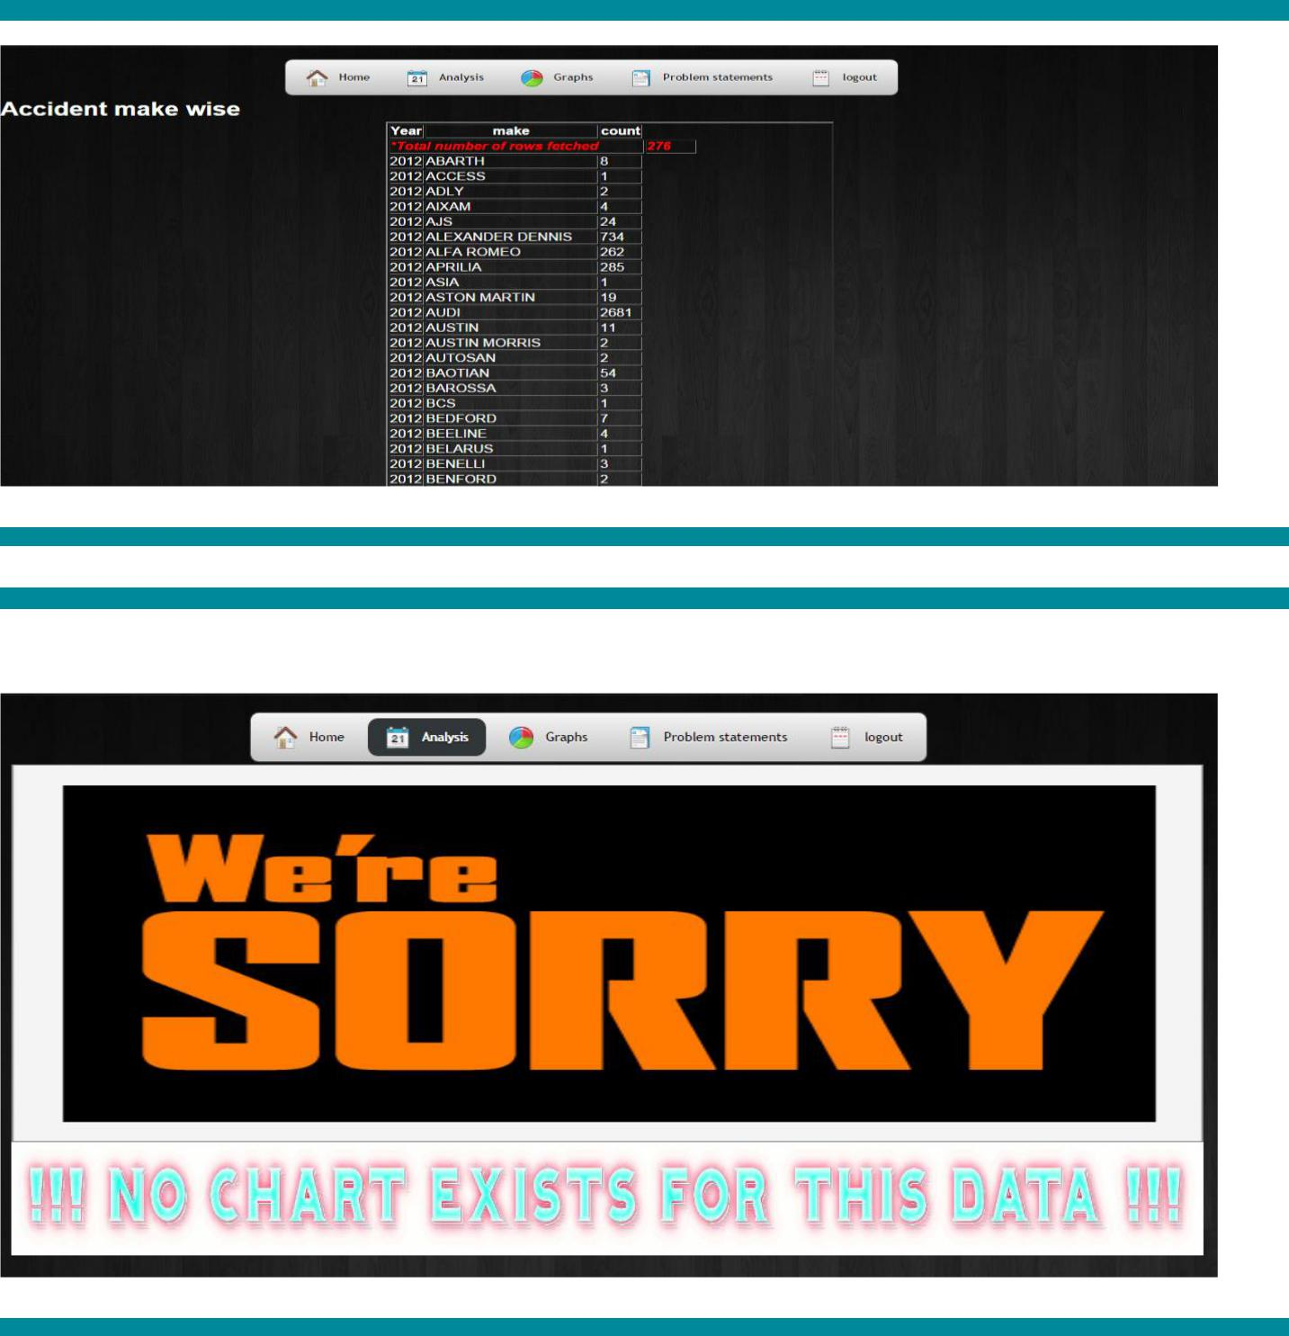

Accidental Analysis Project Report

Casualty
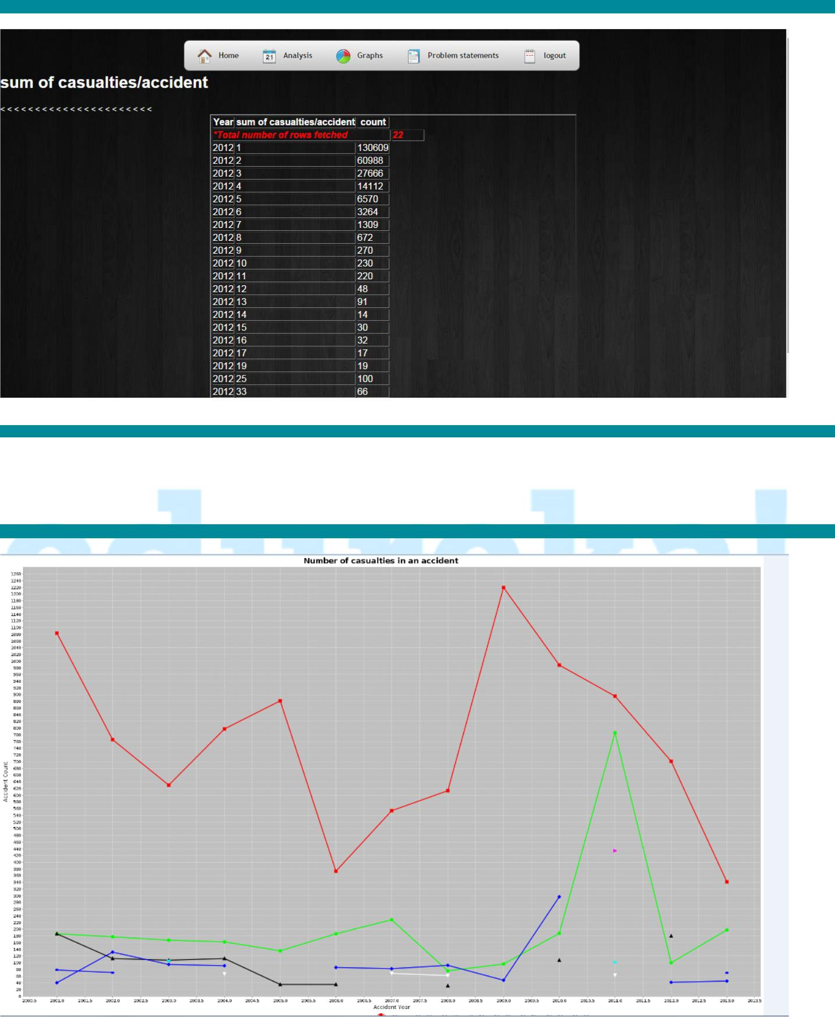

No bar graph exists for this data

Accidental Analysis Project Report

Road Surface
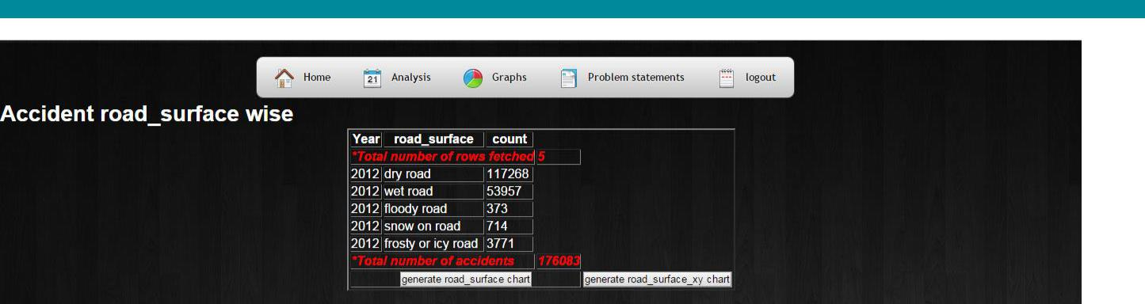
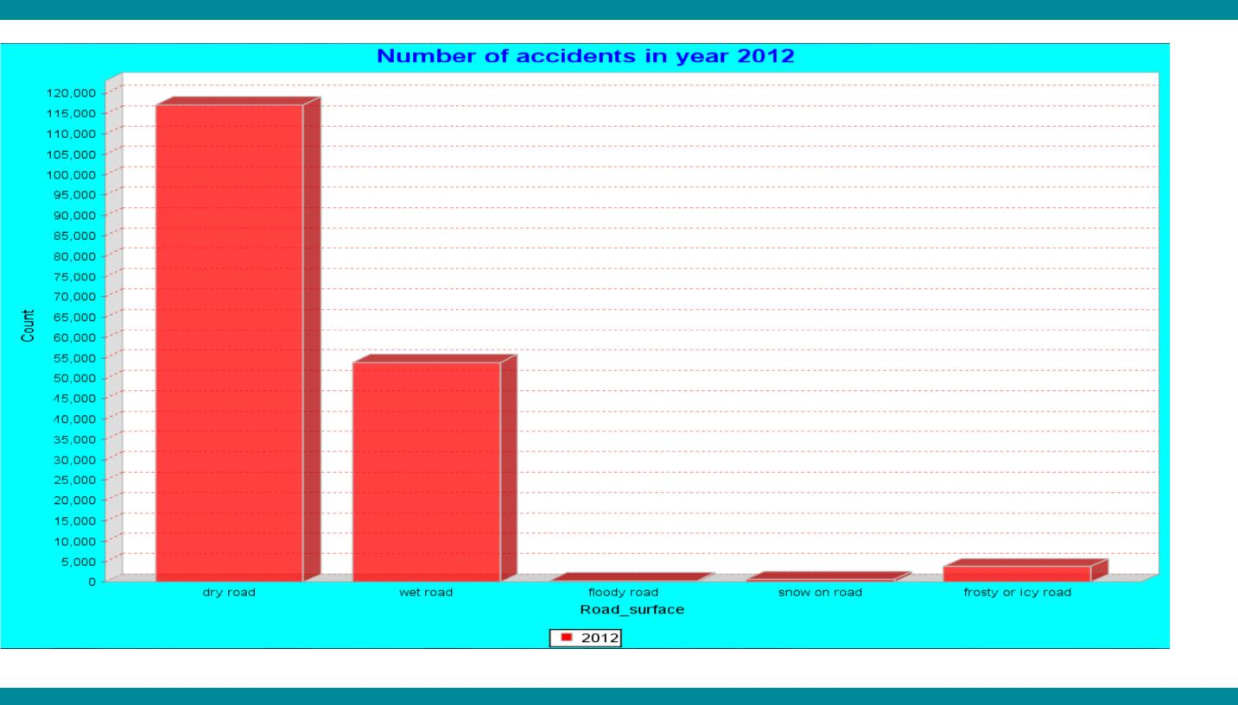

Accidental Analysis Project Report
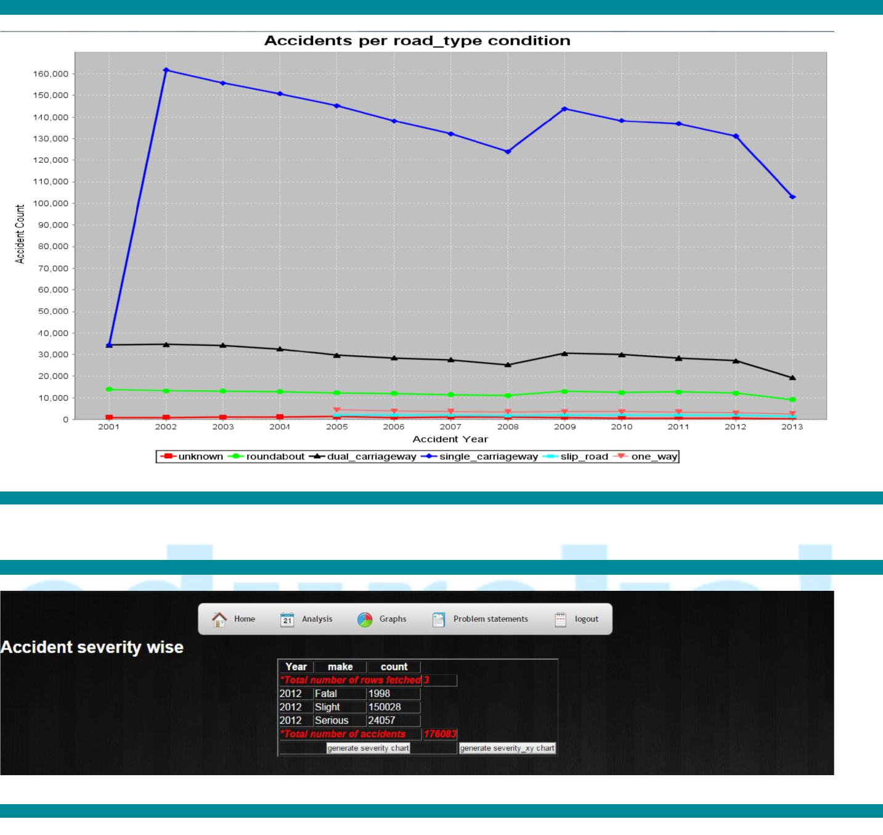

Severity

Accidental Analysis Project Report
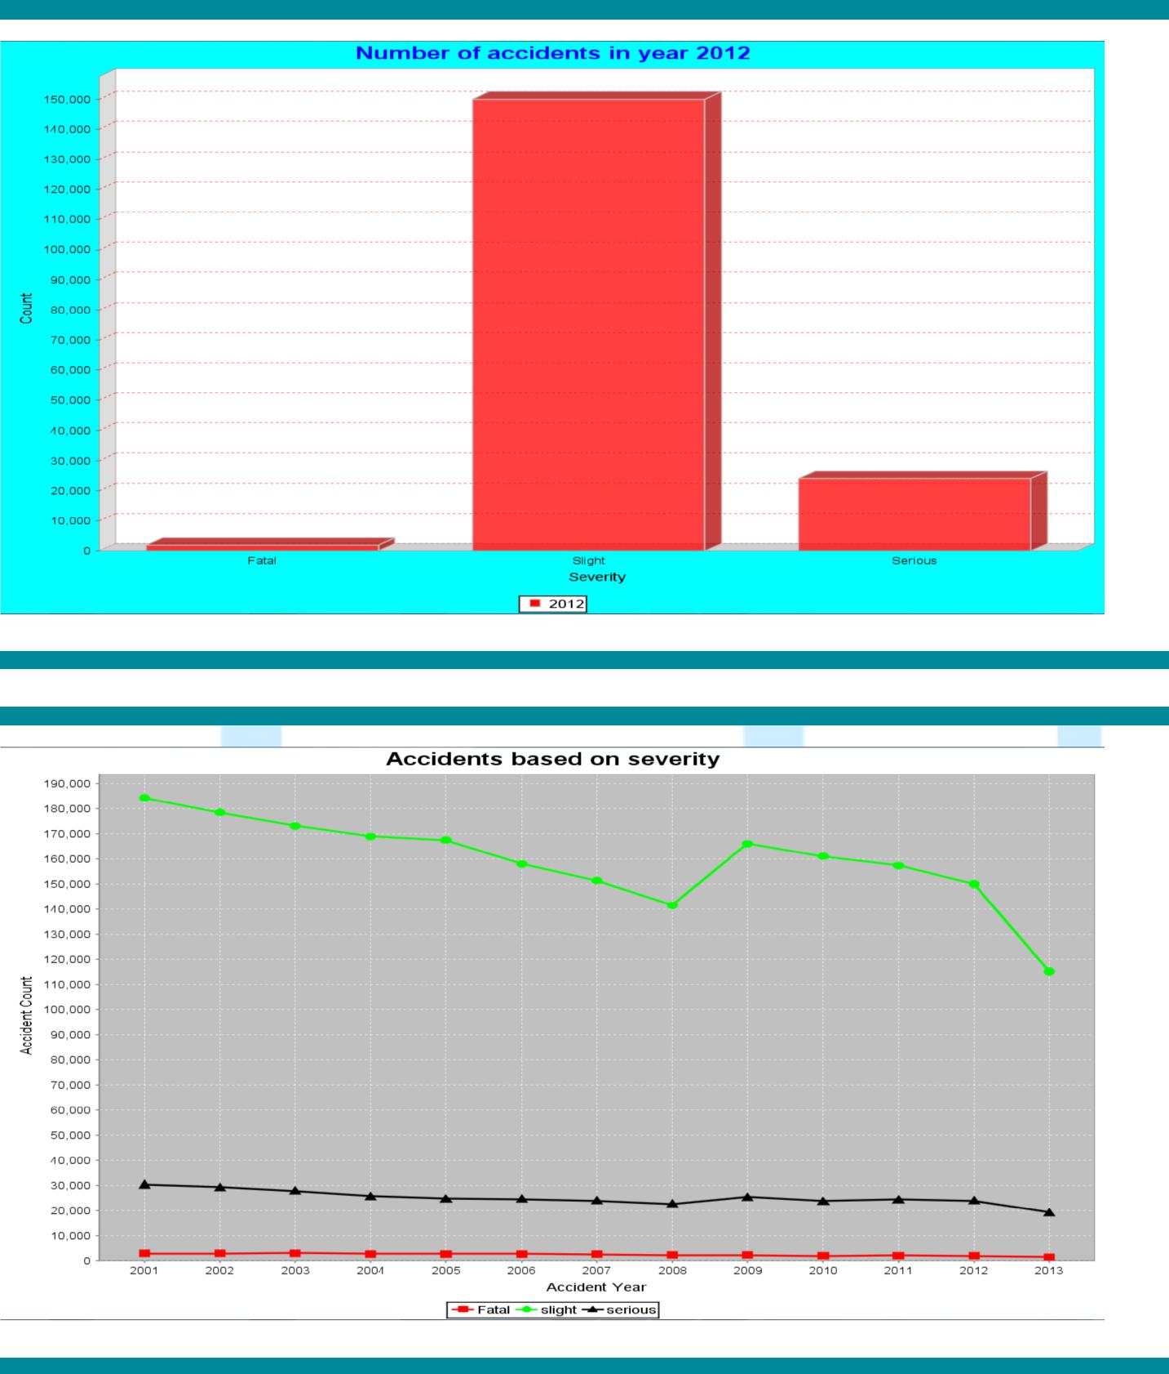

Accidental Analysis Project Report

Speed limit
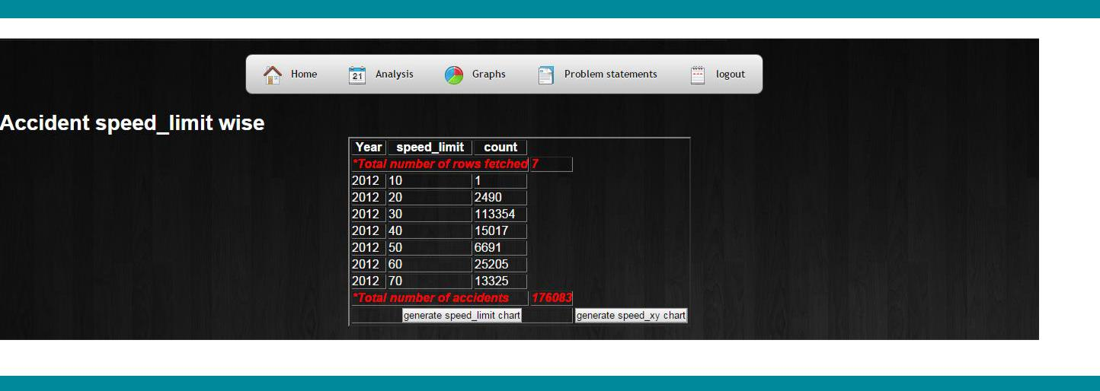

No bar graph exists for this data
